Student’s name | …………………………………………………….…… | Grade | 2
Subject | Computer | Week No. | 6
Lesson Title | Right Click | Unit
Worksheet No. ( 6 ) (Answer)
Instruction: Color the

Color the left click
Color the right click
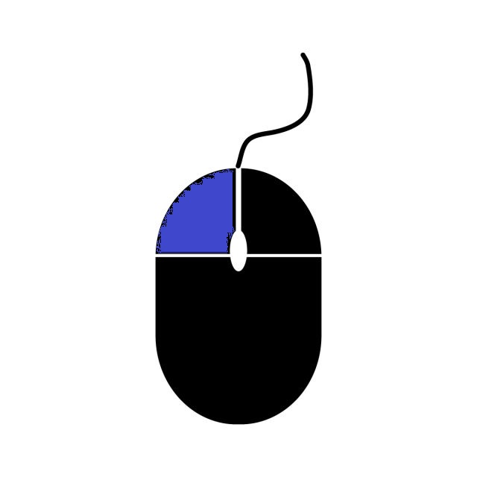
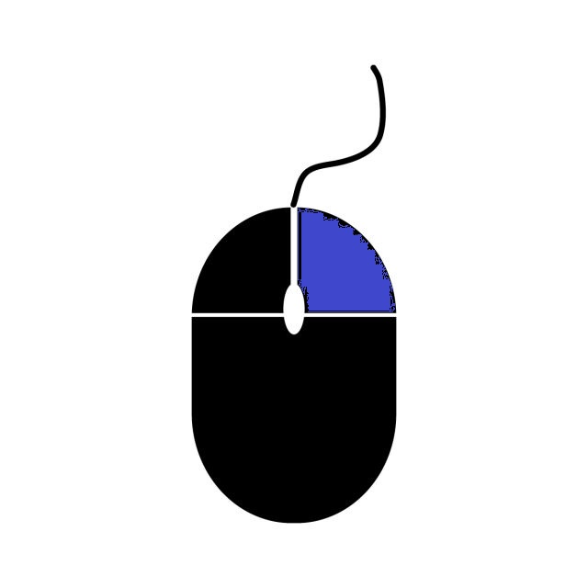
Good Luck

